MAXWELL STREET MARKET, September 16, 2004

Maxwell Street offers the kind of street food you might find in various parts of Mexico. It's interesting because there are things not so much on offer at the neighborhood burrito stand including steamed beef head, birria and its consume, and huitalachoche. There are many places that still work from fresh masa, converting it into pupusas, huaraches, gorditas, empanadas, quesadillas and plain old tacos. You can get meat right off a charcoal fired grill and you can get meat from the nether regions of the cow. How can this not be good eating?
Vital Information

I always feel like Mad Max just arrived in Bartertown and trying to avoid breaking some unknown rule that will get me immediately thrown into the Thunderdome.
Mike G

Maxwell Street Market (which is now actually located on Canal Street) is an avenue of vendors that show up only on Sundays (7:00AM to 3:00PM). There are no street addresses, vendors sometimes switch locations from week-to-week. Usually, though, most vendors stay in pretty much the same place; and some vendors get the same spot year after year.

This work-in-progress guide explores specific stands at the Maxwell Street Market, and provides some guidance as to how you can get what some of us consider the best stuff. One request: if you go to the market, please post about it (and shoot me an email so that I can include your comments in the next version of this guide, which may never be “finished”). My hope is that this guide will be a collaborative effort, with people posting and the guide growing with contributions from many individuals (currently indicated in parentheses).

Send comments to David@DCHammond.com

There’s a map on the last page of this guide.

The vendors in this guide are laid out, more or less, in terms of how you would encounter the stands if you started at the north end (Canal/Taylor) and proceeded to the south end (Canal/14th), but as the market is a fluid affair, it’s not always certain that a specific vendor will stay in the same place from week-to-week.

To get the Gorilla Gourmet video of a 2003 Maxwell Street Market foray, produced and directed by Mike Gebert, and starring Chicago food luminaries such as GWiv, Vital Information, Justjoan, Cathy2, Pdaane, Seth Zurer, and MAG, go to: http://dchammond.com/gorilla/
SALVADORAN PUPUSAS

I’ve seen this place switch from the east to west to east side of the street in the course of a month, but more often than not, it’s located on the block north of Roosevelt Road. It never seems to be very crowed, and I believe it is the only place to sell pupusas at the market. If you’re coming with kids, these puffy cheese-filled disks are likely to make them happy (more happy, for instance, than an eyeball taco, though that dish would certainly give the kids more to talk about at school on Monday).  I asked for cheese, and watched the nice lady push a wad of queso into a fistful of masa, roll it out and start griddling. The fresh pupusa, served with a pickled cabbage, was as good as I’ve ever had. I noticed, though, that the chicharones pupusas were pre-made and sitting in foil, so my guess is that if you had one of those, it may not be as fluffy and fresh tasting. (David Hammond) | 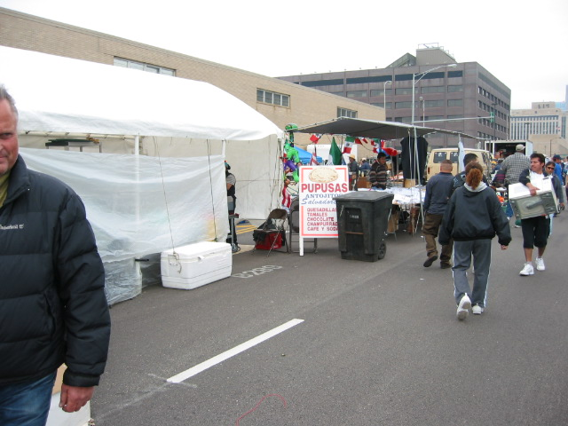
The older lady hand pats the masa and filling while the younger one uses a press. Would be interested to know if others can taste the difference. Ordered one cheese and one bean/pork pupusa ($1.50). The cheese pupusa was bland and seemed more a vehicle for the pickled cabbage/ carrot mixture provided on the tables (excellent, by the way) than a dish standing on its own. The fact that it sat at the edge of the grill for a few minutes probably didn't help. The bean/pork pupusa was awesome. Fresh off the grill, the filling was very beany (and I wouldn't be surprised if there was lard in there). Topped with the cabbage mixture and a smokey red sauce (also on the tables), I left this stand very happy. The pickled cabbage and carrot is slightly sour and slightly hot. The closest taste I can think of is the "brine" of jalapeno slices that people put on nachos. (Mumon) | 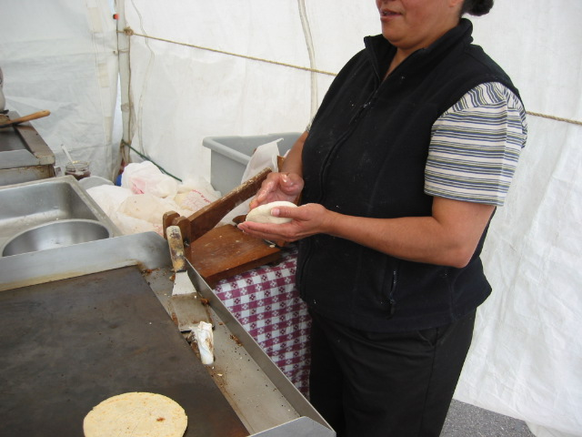
This wins my vote for best food of the excursion. Their tables were full (around 10am), so we ordered two pupusas de frijoles and a tamal de elote to go, per recommendations in "The Guide." We had ample opportunity to watch the pupusa wizards in action. I paid close attention to the technique used to fill the masa with the beans, also watching her cues for determining when the pupusa was finished grilling…As it was yet another chance to practice my Spanish, I had some brief conversation with la Madre, who seemed pleased that a gringa was a) speaking Spanish with her and b) purposely stopping at her booth. Definitely recommend adding the table salsa and pickled cabbage for a fantastic pupusa, and thanks to VI for the advice about adding crema to the tamal de elote. (Mags Thomas)  The Salvadoran place remains one of my favorite places to eat. (Vital Information) | 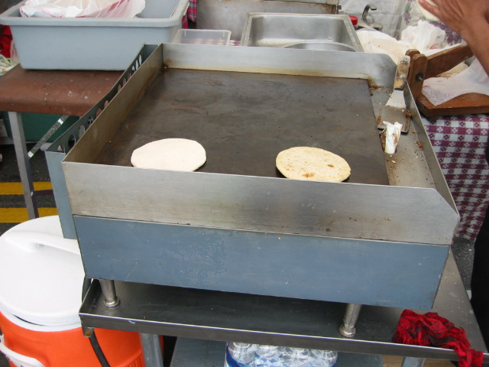
At the pupusa stand, don't miss the tamales de elote. These are the ones made from (fresh) ground corn kernels NOT from masa. They're fabulous. Be careful: she has both kinds, both good. But I think that the tamal de elote with a drizzle of "sour cream" is really special. (RST) | 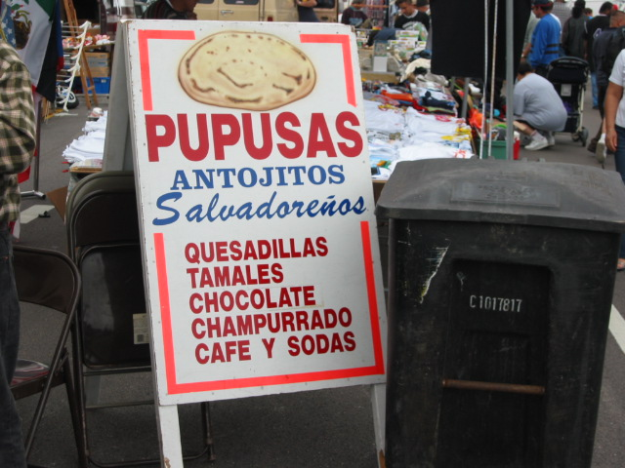

FRESH PRODUCE

There are fresh produce stands all over the market, though they are most prevalent around Roosevelt Road (which is convenient if you can coordinate with a friend to swing by and pick up you and your produce; the only downside of this fresh, heavily discounted fruit and veg is that you have to lug it out of the market). I’ve bought many items at the place right in front of the White Palace, and the deals are incredible (e.g., fresh raspberries and blackberries at something like $10 a case); I’ve only been disappointed once, with some pineapple that tasted chemical-ly (like maybe some gas had been used to speed the ripening process – this bad experience was a one-time instance). | 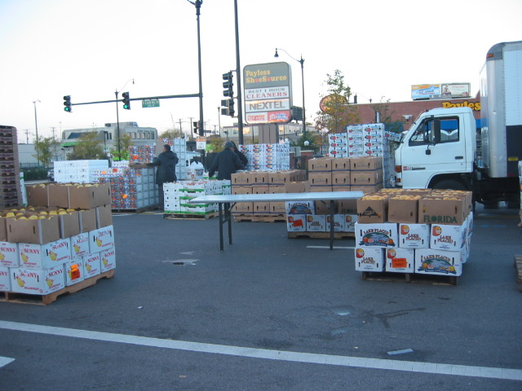
For semi-tropical fruits like papaya and mango, you can usually count on a fairly large selection. I’ve frequently seen families shopping here for the week’s groceries; if I lived closer, I’d do the same thing.  Justjoan swears by these tiny, yellow mangoes; they are very sweet, and seem to yield a lot of fruit. I have seen three teenage girls tear through a case of these in an afternoon. | 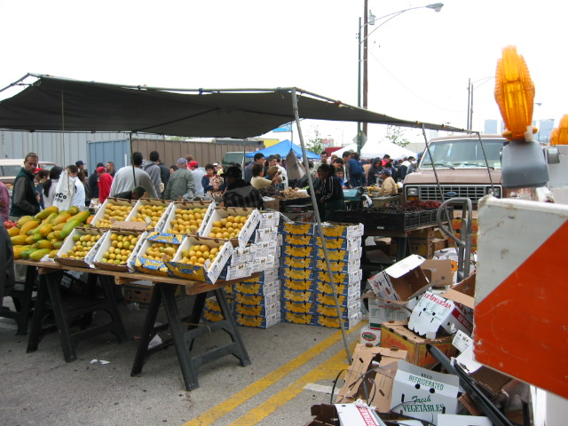
Call me overly hygienic, but this just might be the kind of Maxwell Street fare you should avoid. Even if the price is right, even if you love gummies and sugar-coated nuts, are you sure you want to buy them from open containers that have been exposed to the sun (and the sneezes and goober-encrusted fingers of children) for perhaps several Sundays before they reach your mouth? | 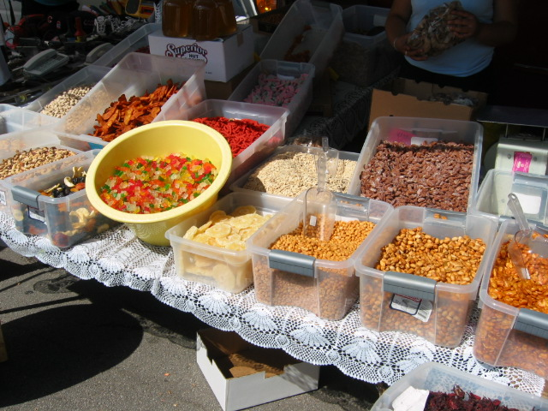
This is huanztontle (or at least that’s how one vendor spelled it). It’s available in the early part of the summer, and it has a deep green spinach-like flavor. I’ve had it cooked in an egg-batter and Rubi’s, and while it was edible, I would not order it again. It actually seems like one of those foods that should only be eaten if you’re trapped in a city under siege and have few alternatives. | 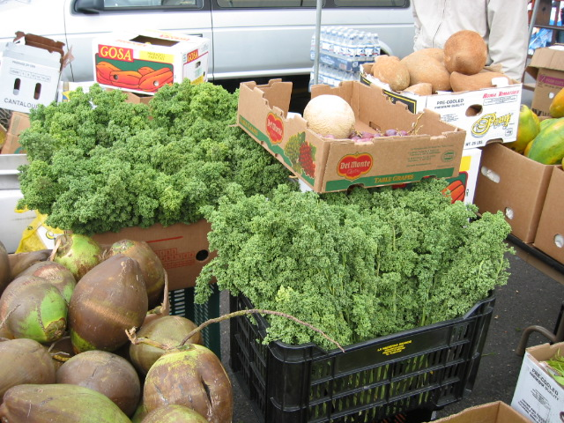
For dried peppers, the price and selection at the market are very good. What’s nice is that you can buy a relatively small quantity (say, a few ounces), use it for dinner, and not have to stare at an half-used package of peppers in your cabinet for the next six months.  Also, as you can see, you can get the fresh peppers and an array of unusual candy at many stalls. (David Hammond) | 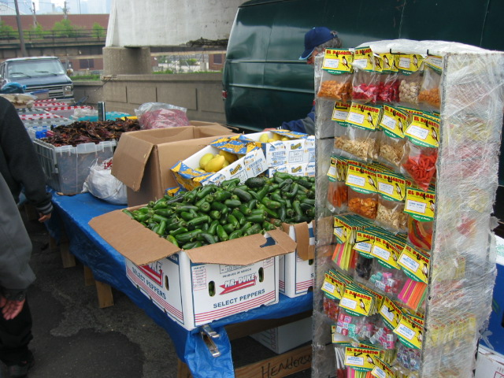

EYEBALL TACO PLACE

The ojo taco stand in the western "corridor" on Canal. I tried the ojo taco ($1.25) again today and it was much better than the one I had last week. Served by Mario (who was managing the grill today), a friendly boy wearing a powder blue "Players" cap, he recognized me from last weekend and seemingly selected some choice ojo pieces. This week I got an entire eye, some connective tissue, some meat that had the consistency of chicken gizzard, and some regular head meat. All of this was filmed with melted fat and collagen, giving a satiny mouthfeel. If you consider the head of a fish to be more highly prized than the fillets, then this taco is for you. If "connective tissue" cannot conceivably sound appetizing to you, then please avoid and try the cachete (cheek) taco instead. This taco also has the fat/collagen film, which I consider to be very appealing. I asked what animal's eye I was eating and was told cow by two of the employees. As speculated previously, a different answer may result if the question is asked in Spanish. I plan to return with Spanish speaking friends. The meat itself tasted gamier than standard beef, but then again I have little experience with flavors of the head. Two other words about this place. First, their tortillas are treated somewhat differently from most other places. The prefab tortillas are first dipped in rendered/ simmering chorizo fat, then dried on a grill, then placed in the corner of the "head" grill. The grill is tilted in a way that the fat/ collagen/ juice collects where the tortillas are stacked. So, unless you get the top ones, you'll end up with soggy, head juice and chorizo fat laden tortillas. Now, that doesn't sound appetizing even to me. Second, they had new signs up this week and next to the ojo taco was written "Grasias por preferirnos". I don't read Spanish, but I imagine that this says something like "Thank you for liking these". They were clearly popular with many of the Mexicans anchored in the ten or so seats provided. (Mumon) | 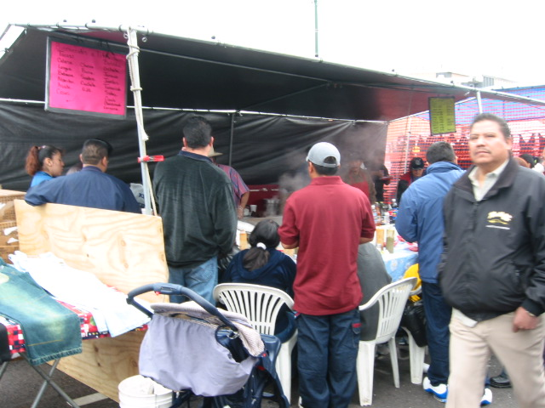
To try to describe the indescribable, goat eye, at least in the Maxwell Street Market preparation, has the combined texture of over stewed meat, slightly raw sweetbreads, laced with stringy bits of gummy/stringy ocular nerve endings. The flavor is very 'organ meat' but in a concentrated way, think cow, not calf, liver mixed with the extra offal goodness of brain. (Gary “Ultimo” Wiviott)  Any ever realize there are not one but two purveyors of steamed beef head (which may include the ocular)? A while back, it was reported that the eyeball taco guys had opened a brick and mortar shop in Berwyn, El Chimbombo. I always assumed this was the place featured in the Gorilla Gourmet video. No. And on Sunday, that place and El Chimbombo stood across from each other, offering to give head. El Chimbombo made much more clear the offerings. If you knew Spanish, the words cheeks, lips and eyes were in big letters. The other guys kinda hide what's there. I skipped both. (Vital Information) | 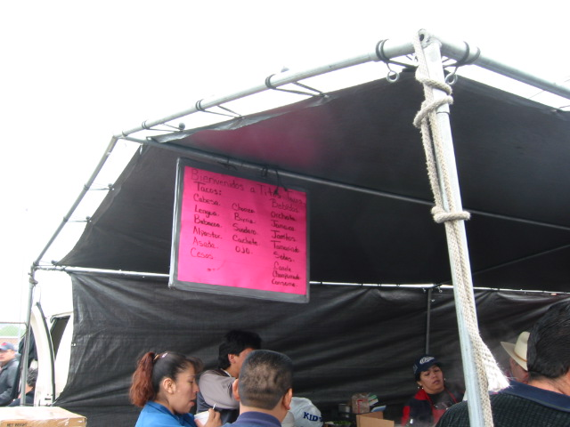
My daughter brought a bunch of college friend home to visit the Maxwell Street market (apparently, the Gorilla Gourmet video has a cult following on at least one Michigan campus). High on one person’s list of Must Try items were the eyeball tacos. He took a bite and made a face, and seemed like he would stop eating…so my daughter helped him finish. (David Hammond) | 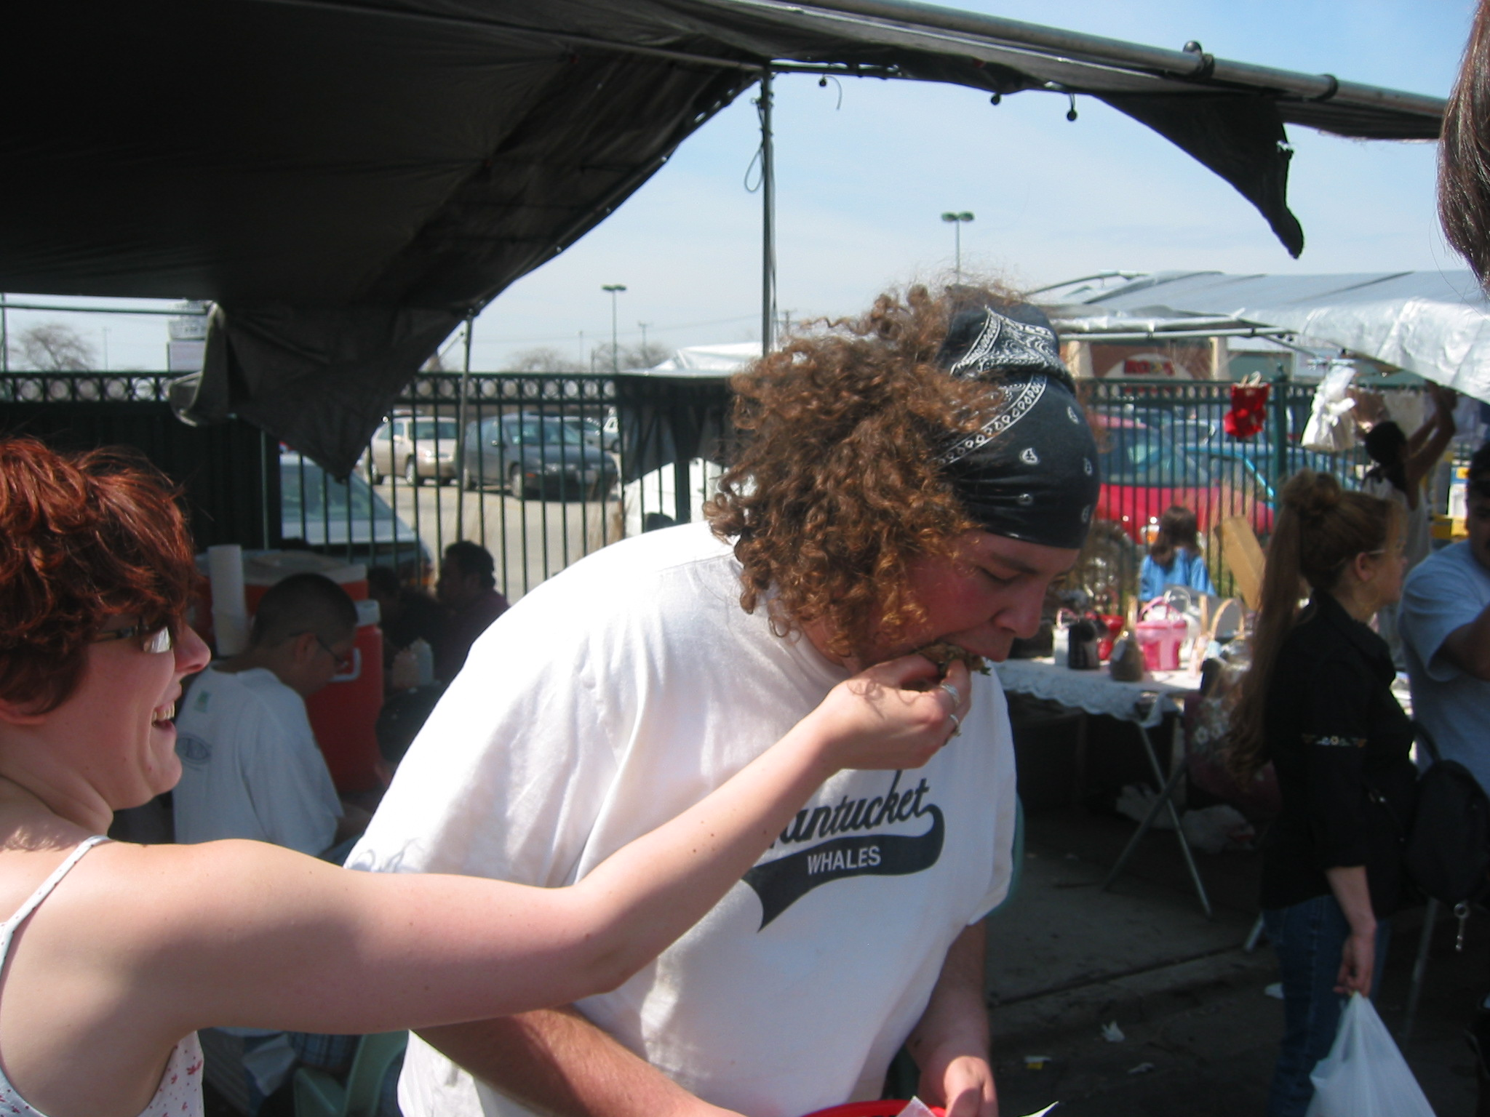

TACOS BERNARDO

Tacos Bernardo has the distinct advantage of usually being in pretty much the same place every time I go to the Maxwell Street Market. It’s on the east side of the street, about three-quarters of a block north of Roosevelt Road.  Tacos Bernardo, to the best of my knowledge, has not been mentioned on any of the Chicago food boards. It’s a fairly non-descript place, with corrugated cardboard walls and a tired sign featuring an uninteresting generic taco. | 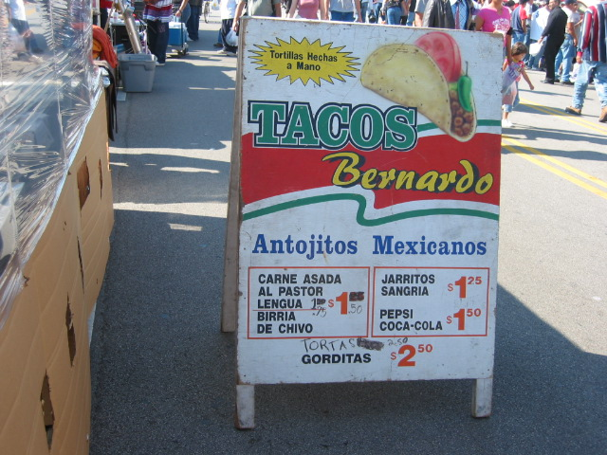
Then one Sunday, I was walking by this place, and getting ready to ignore it again, I spotted some little Dixie cups of green stuff on the tables.  I queried a young server, “Que es esto?”  “It’s for the tacos,” she replied, with the clear subtext, “Another day, another gringo trying out his high school Spanish on me.”  Switching to my native tongue, in which I seem to have more facility, I said, “Oh, but what is it?” {beat, beat} “Oregano” (which I knew it wasn’t, but I wanted to convey that my goal was to identify the vegetable itself)  “Papalo,” she said, and turned back to serve paying customers. | 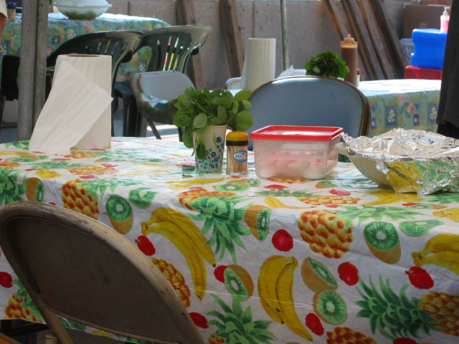

Back story: Over the last year of so, many of us (Gary, Eric, Justjoan, C2, VI, Seth, Giovanna, and others.) have gone to La Puebla, seeking the delicious sandwiches that allegedly feature the mysterious “papalo” – a critical ingredient, or so we are told, that seems never to be available at this place.  As a result, papalo has achieved legendary stature (at least in my mind), and so when the server said “Papalo,” it was almost like in high school, when Kathy Zerfoss said “Yes, yes I will yes” or the first college I ever applied to said “You’ve got the position” – a whole new world of possibilities opened up.  Okay, I’m not going to say that eating this plant was quite as good as first-time sex or landing a professorship right out of grad school, but I can understand why it is revered as a noble accompaniment to a meat sandwich.  I broke off some leaves, crushed them a little and massaged them gently to release their deliciousness, and then laid them on the steaming meat, the heat of which seemed to liberate essential oils, so that leaf and meat merged into a single flavorful mouthful smacking of the savory steak but also, distinctly and with equal power, the bland, vegetal earthiness of the papalo.  Unexpectedly discovering cups full of papalo is a perfect example of Maxwell Street serendipity: you never know what you’re going to run into, but a lot of times, it’s surprising and intensely pleasing. | 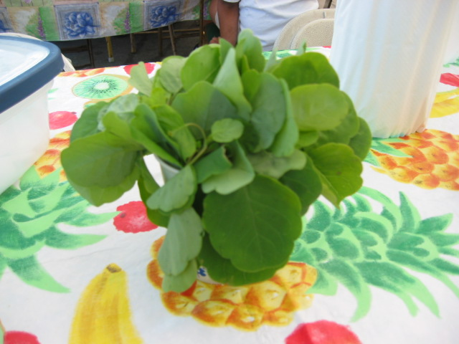
Eating the leaves straight-up is somewhat satisfying, but it seems like one must strain a little for the flavor.  This is my friend Beret. She is Norwegian. This is how she looks when she eats papalo. Notice that she is concentrating on the flavor. (David Hammond) | 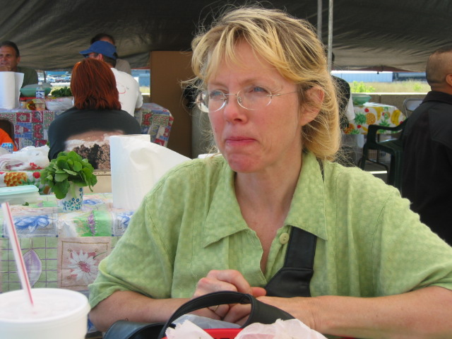

RICOS HUARACHES & DELCIOSOS COKCETELES

What I like most about the sister stands of Ricos Huaraches and Deliciosos Cokcteles is that you can get some surf, turf, a beverage, and a place to sit. It’s comfortable and has a range of foods available. | 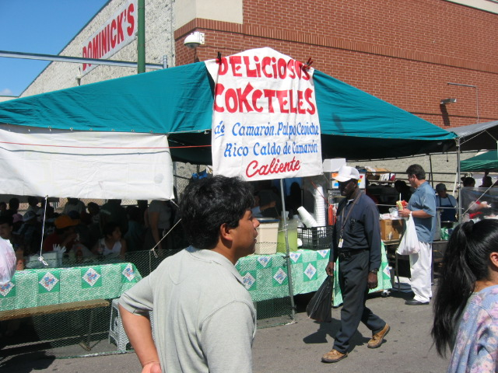
In the manner of many immigrant groups who come to this country, cooperation and shared commerce is the norm. Ricos Huaraches and Deliciosos Cokcteles (sic) are two separate though united operations working under “one big tent,” much like Rubi’s/Manolo’s further south on Canal.  As you can see from the picture on the right, this double-whammy stand is located at the southeast corner of the Dominick’s; that’s on Canal Street, about 1.5 blocks south of Roosevelt Road. | 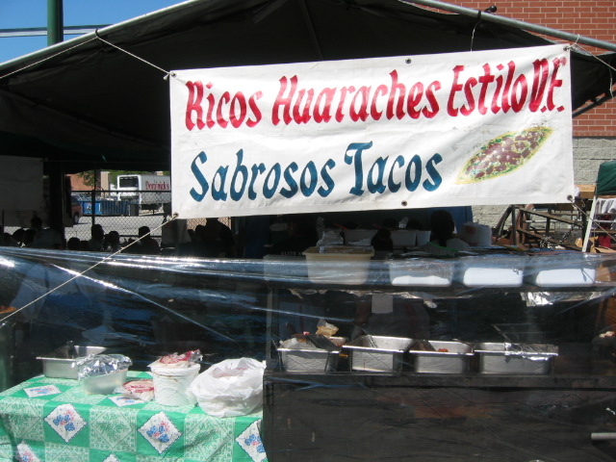

Don’t believe the sign: you don’t actually have to order and pay at the same time: first you order, then you wait in line, then you pay.  Here’s how you do it: when you come into the restaurant via the south entrance (really the only way to walk in the place), you will probably find a line. Take your place in line, and when the man with the pad comes up to you, give your order (see menu, next shot).  You will then get a receipt, which you hold until you get to the register where you pay. If you see seats open up while you’re waiting, have someone sit in them while you wait to pay (seats are at a premium, and people dive on them when they open up).  Hang onto the receipt because when the order is ready, they will call your number. They usually call the numbers only in Spanish, so you will need to use your fifth grade Espagnol – or just sit there looking innocent and hungry, and chances are, after the waitress has called your number a few times, they’ll pretty much assume you’re the one whose order is ready and they’ll bring it to you (at which point you can simply display the receipt, look stupid, and receive your food and a benign smile). | 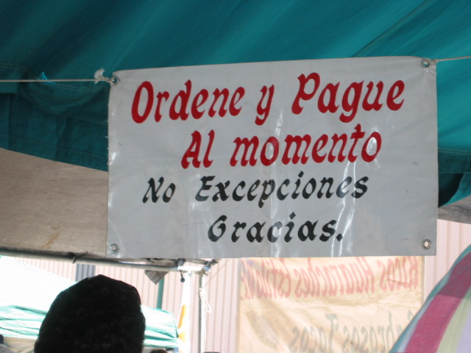
Here’s the menu, which is posted at several spots inside the tents.  The menu is mostly, as the names imply, huaraches and cocktel, and they also have soda, horchata, and juices. | 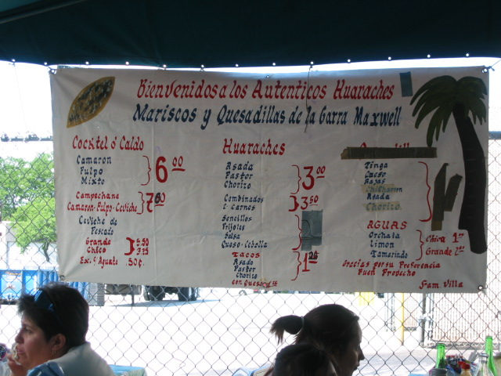
This is one of my favorites. It’s the combo cocktail with shrimp and octopus. $6 bucks a pop.  They are generous with the servings, and there’s probably 8 or so shrimp in each cup, plus a healthy bunch of very tender, tasty purple octo-hunks.  Note tongue of catsup licking over side (see next shot for preparation information).  Cocktail is served with tostadas, which make excellent “spoons” when dining with a large group (they do have regular spoons and lots of napkins on the tables). | 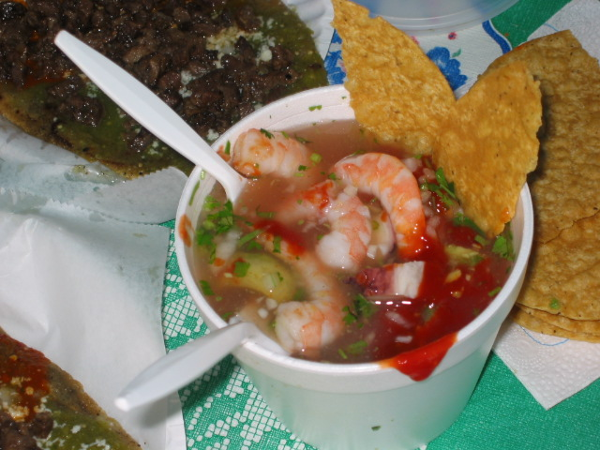

The cocktails are made with remarkably simple ingredients:  - Seafood  - Mix of cilantro and onion  - Shot of lime and hot sauce (optional)  - Catsup (unabashed dollop)  It’s that easy. | 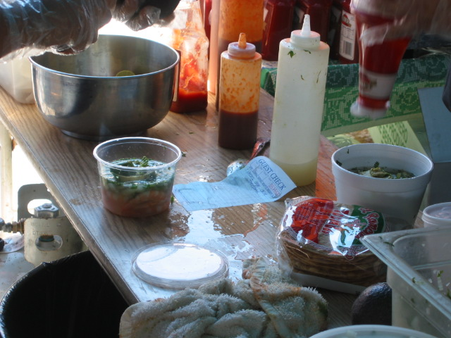
This is the combo ceviche we ordered. It was exceptionally mild marinated whitefish on tostadas with slices of avocado (50 cents more for extra avocado).  This is a good “neutral” dish that would appeal to anyone in the group who likes their Mexican non-spicy and who isn’t freaked out by eating “uncooked” fish (the fish is “cooked” in the marinade, so it’s not sushi, but it’s also not been exposed to heat)  This ceviche was a good complement to the other dishes we got, but I wouldn’t have it all by itself: there’s not enough there (though, with green and red salsa readily available, you can always pump up any entrée with a few thousand Scoville units of heat). | 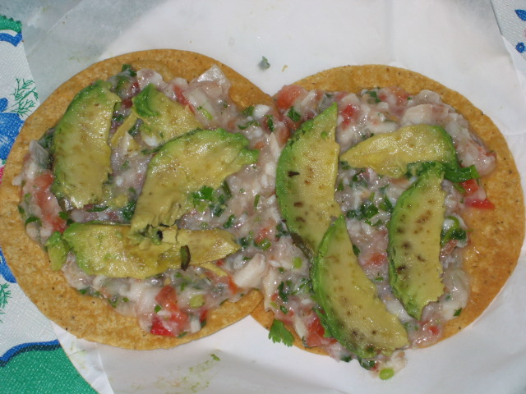
Here are three huaraches, which are “slippers” of masa, filled with a center of finely ground bean paste, and fried on a hot griddle. $3 each.  For bandera (“flag”) style, you get red sauce, the somewhat milder green sauce, and white Chihuahua cheese (the colors of the Mexican flag…get it?). We had carne asada sprinkled on top, and this is one delicious fistful of food. It’s messy as hell (napkins, as mentioned, are abundant), but worth it.  Everyone I’ve ever introduced this to has loved it. I would consider this a must-have dish. | 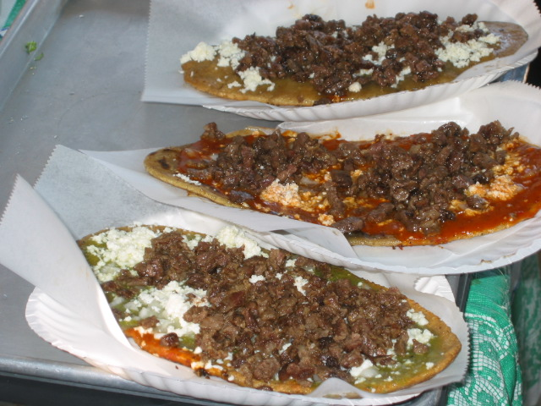
Maidens of Masa at work.  Note big tray of corn meal in foreground. They grab a fist of dough, work some beans into the center, put the whole thing in a press, flatten it into an oblong plate, and griddle it.  Notice that they use their hands to move ovoid masa disks on and off the grill – no spatulas in sight.  Amazing fact: it’s REALLY hot back here in the kitchen, what with griddles and flaming pots every where, but none of the Maidens seemed to have broken a sweat. | 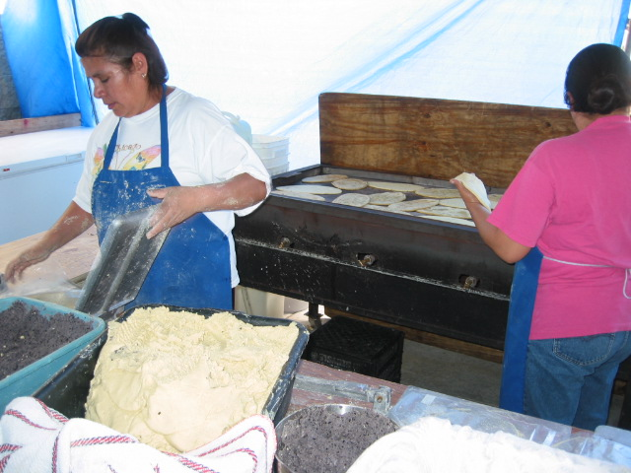

Here’s a shot of my table before we were served.  The accommodations are tight, but everyone seems exceptionally friendly and the general vibe is quite welcoming. Lots of kids running around looking for fun, families spending a day together, it’s nice. (David Hammond) | 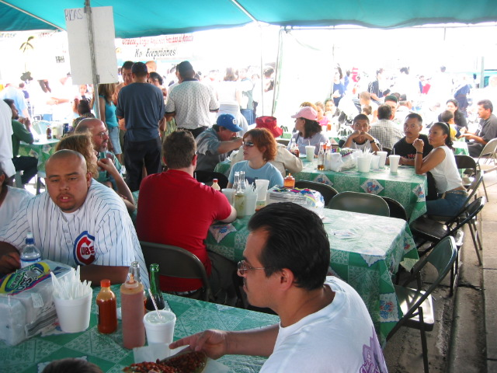

TAMAL OAXACA

Tamal Oaxaca is my favorite Maxwell Street Market stop.  It is also located in just about the same place every time I go. When you’re exiting the parking lot of the Dominick’s (where you should NEVER park if you are going to the Maxwell Street market), just go to your right for about 30 yards, and Tamal Oaxaca will be on your left (east side of the street) | 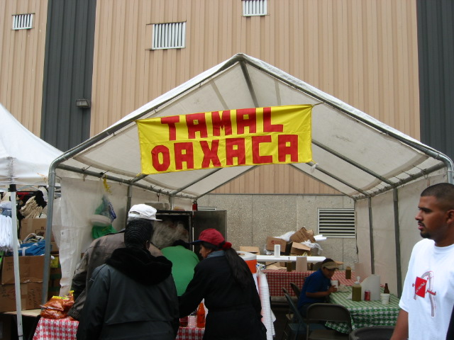
Here is a platter of Oaxacan tamales.  From left to right, there’s chicken in the small version, the big green classic Oaxacan tamale (my favorite, full of chicken), and the spicy pork. Below is the strawberry tamale, which is not very sweet, but tastes a lot of corn (I, personally, do not recommend it – there’s not much there there).  No one who has ever eaten a Oaxacan tamale has ever not liked it.  It is a guaranteed pleaser, full of stringy-soft stewed chicken chunks, in a carboholic’s dream of masa, steamed in a banana leaf, which somewhat surprisingly imparts a great deal of flavor, and is also fun to open up.  I am so enamored of this Native American food, I even wrote a poem about it (following) | 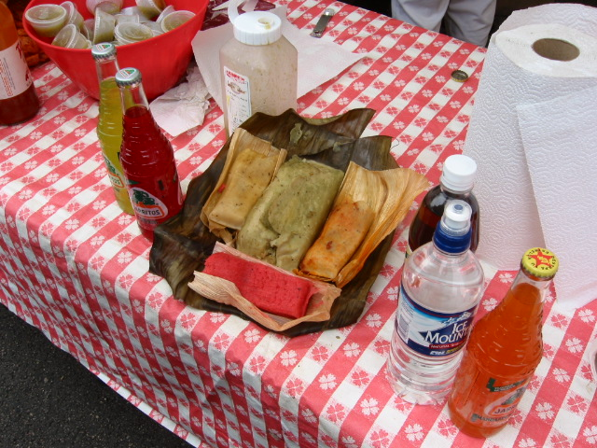
After you’ve grabbed your Oaxacan tamale, I’d recommend trying to snag a seat in the back. There is actually room for 20 or so people in the small tent, but seats here, as elsewhere in the market, are usually at a premium. The reason I suggest eating while seated is that it’s sometimes tough to juggle a big tamale, swimming in hot sauce and sour cream, on a plastic platter, amidst a crush of humanity (I’ve done it many times, but it’s nicer to sit, contemplate the beauty of the tamal, and savor). (David Hammond) | 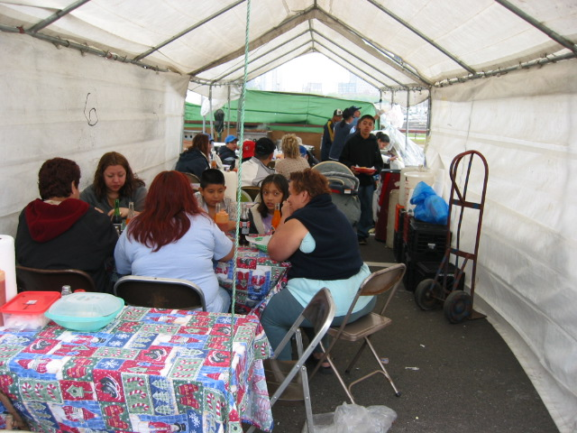

THIRTEEN WAYS OF LOOKING A OAXACAN TAMALE, Maxwell Street Market, November 24, 2002

I  Among a hundred stalls,  The only one that sang to me,  Was Tamal Oaxaca.  II  I was of three minds,  Like a plate,  On which there are three tamales.  III  The tamale was the still point  Amidst the swirling Sunday market.  IV  A man and a tamale  Are one.  A man and a tamale and a beer  Are one.  V  I do no know which I prefer,  The beauty of the taste,  Or the beauty of satiety;  The tamale being eaten,  Or just after.  VI  Tamales fill the silver chest.  Green bricks of goodness;  My own was withdrawn,  And, lifted to me on a plate,  Its unfolding aroma  Raised in me  An unquenchable hunger. | VII  O thin tamales of Tom Tom,  How dare you present yourselves to me!  Do you not know that the Oaxacan tamale  Is the bright sun under which you  Slither, pale yellow shadows?  VIII  I know fine words  And laughing lines  But I know too  That the Oaxaca, tamale is involved  In what I do.  IX  When the tamale disappeared from my plate,  It marked the first  Of many more.  X  With the scent of Oaxacan tamales  Drifting on the wind  Even the bland children of Banquet  Stand up and drool for their deliciousness.  XI  He rode through the Oak Park night  In a silver car.  Once, a fierce hunger pierced him  In that he mistook  The blurred green moon  For a Oaxacan tamale. | XII  The stomach is growling.  The tamale is steaming.  XII  It was dinnertime all afternoon.  I was hungry,  And I was going to be hungry.  The Oaxacan tamale unwrapped  Across my plate, waiting.

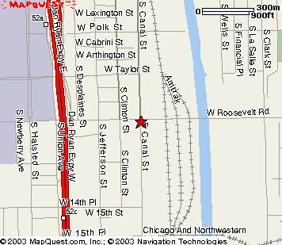

The market is open only on Sundays, from 7:00 AM until 3:00 PM. If you’re shopping for anything other than food (e.g., ancient tools, 8-track tapes, etc.), the real deals kick in around 1:00 PM: Bossman’s Bargains, for instance, discounts everything on the front tables to 25 cents!!

Here’s a map that will help you find Maxwell Street (which is actually located on Canal Street). There’s street parking all around, but if you come after 8:30 AM, you may have to search a while. Around 8:00 AM, there seems to be a lot of movement on Canal, north of Roosevelt, when the post office nightshift gets off work.

